NCADP COMPUTERS PART III

ASSIGNMENT # 3

Slide Show Presentation – MS PowerPoint

RATIONALE

Most students enjoy the creative process and easily get bored when they are continually asked to present their material using just pencil and paper. The computer can be an extremely useful tool for letting our creativity loose. Students of all ages and abilities can be ‘turned on’ when doing a project on the computer.

Slide show or Presentation software allows students to create a truly multimedia experience that they will enjoy creating and others will enjoy watching.

PURPOSE

For this assignment students must create a ‘slide show presentation’ using Microsoft PowerPoint. The assignment should include the following;
- A set of at least 8 slides, each with a background, title and display of information/pictures;
- A Title slide that includes a title (of course), a brief description of the presentation, and your name;
- A Table of Contents slide that includes a listing of the slides and a hyperlink to each slide.
- A half-page reflection that includes the following – your views on using presentation software with students, what you found challenging or easy in doing this assignment.

STEPS

- The following page provides an example of an autobiographical slide show. Note the components of each slide.
- Choose a topic of your own. Possible topics include an animal, a country, dinosaurs, my family, etc.
- On paper sketch out the basic content of your slide show
- Start Microsoft PowerPoint and create a new presentation. Add the new information/pictures to each slide. Finish by adding a background, adjust formatting if necessary, add your hyperlinks to the Table of Contents, print a copy.
- Complete the reflection and hand in your assignment.

DUE DATE

This assignment is due on Wednesday, July 8, 2009 at 4:00 p.m. It can be submitted in class or to the NCADP office.
NCADP COMPUTERS PART III
ASSIGNMENT # 3

Slide Show Presentation – MS PowerPoint

The diagrams below illustrate the main components of each slide.

Contents Slide
Lists each section in the presentation

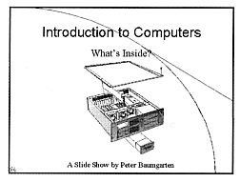
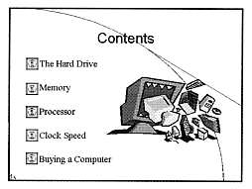
Title Slide
Includes title, description and name
Sound has been inserted
Buttons are inserted that link to different slides
Clipart or photos are inserted

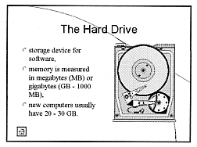
Information Slides
Describes each topic in the presentation
This button links back to the Contents page
Include clipart or photos to illustrate your slide show.
Include information that is written at the level of your audience.
NCADP COMPUTERS PART III

ASSIGNMENT # 3

Slide Show Presentation– MS PowerPoint
Rubric

Name:

Slide Show
Level 1 | Level 2 | Level 3 | Level 4
Fewer than 8 slides; Title and/or Contents missing | Fewer than 8 slides including Title and Contents. | Minimum of 8 slides including Title and Contents | More than 8 slides including Title and Contents.
Missing several of background, and appropriate titles and pictures | Appropriate background, and some appropriate titles and pictures | Appropriate background, titles and pictures | Excellent choice background, titles and pictures
Contents slide missing several sections and/or workable links | Contents slide includes most sections and/or workable links | Contents slide includes all sections and workable links | Contents slide well designed and includes all sections and workable links
None of the following features included; slide transitions, animation effects, sound. | One of the following features included; slide transitions, animation effects, sound. | Two of the following features included; slide transitions, animation effects, sound. | All of the following features included; slide transitions, animation effects, sound.

Reflection
Level 1 | Level 2 | Level 3 | Level 4
Few or none of the required components included | Some of the required components included | All required components included | More than the required components included
Many mistakes in writing | Minor mistakes in writing | well written | Exceptional writing style

Final Grade  25 | Comments

